Attachment 4:
2026 Wenzhou International Design Biennial
Requirements and Specifications for Movable-type Printing Creation Design Competition

Rui'anmu movable-type printing technology, as the only surviving movable-type printing technique still in use in China, was selected as a national intangible cultural heritage in 2008. In 2010, as an important component of "Chinese movable type printing technology", it was included in the "List of Intangible Cultural Heritage in Urgent Need of Protection" by UNESCO. This ancient technique carries the wisdom of Chinese civilization, but now it faces the challenge of inheritance gaps in the process of modernization.
To solve this dilemma, the competition takes "national participation, cross-border integration, and dynamic inheritance" as its core concept, and sets up a special design competition called "Movable-type Printing Creation Design Competition: Movable-type Printing Public Innovation Plan" to promote the transformation of wooden typography technology from "static protection" to "dynamic inheritance".
- Scope of works
1.1 Life aesthetic products
Including consumer goods, lighting fixtures, tea sets, stationery, home furnishings, incense burners, gifts, etc. that enter daily life.
1.2 Teaching aids experience package
Including lettering toolkits, portable typesetting box, printing experience set, etc. used for intangible cultural heritage education/experience scenarios.
1.3 Public art or facilities
Including wooden movable type application landscape installations, interactive walls, public seating, signage systems, etc. in urban, community, and cultural spaces

Eligible products are included but not limited to products used in daily life and production.

- Specifications of submission
1. Display board image
One vertical display board, arranged in a 700mm × 1000mm vertical pattern, with a resolution of 300dpi. In addition to simple design instructions, the image content should reflect the overall picture of the work, and hardware products should be labeled with information such as the size (length x width x height cm) and material of the work. It is required to have multiple angles, reference objects, and reflect the original appearance of the work as much as possible;
The image format should be unified as jpg or CMYK mode, and the size of a single image should not exceed 80M. The graphic should include a brief design description that can assist in explaining the design intention and features of the work. The number of characters is not limited, but the language and text should be Chinese (traditional or simplified) or English. The display board should have a graphic recognition template for the Wenzhou International Design Biennial, which can be downloaded from the official website (http://wzdb. zjcst. edu. cn/).

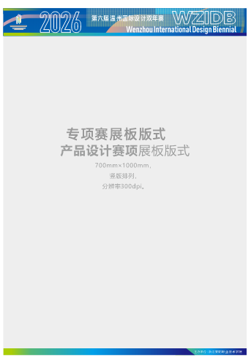
2. Works review images
The image format is unified as JPG, with one 210mm * 290mm image and a brief design description attached. Horizontal and vertical unlimited, resolution of 300dpi, RGB mode. The size of a single image should not exceed 20M.
3. Video file description
Additional videos and roaming animations can be added, which is an additional item and not a mandatory requirement. The video format is MP4, and the demonstration video in the same competition topic should not exceed 100M, not be less than 20M, with a clarity of 1080p, a time limit of no more than 5 minutes, and a display ratio of 16:9 to ensure image quality.
4. Work description
The description should be within 500 words, and able to clearly express the creative ideas, content, sources of inspiration, application of cultural elements, and usage scenarios of the work.
3、 Award Setting
This competition has one gold award, two silver awards, four bronze awards, and several design awards. Winners will receive a certificate of award and corresponding prize money (before tax).
The bonus amount is as follows:
Category | Gold award | Silver Award | Bronze Award | Design Award
Product | 10000 | 5000 | 3000 | 1000
The prize includes model fees: the winning work model will be collected by the competition party. If the participating work is not suitable for collection, a reduced version model can be made. If the value of the work exceeds the bonus, participants can negotiate with the committee to make up the difference.

- Copyright Ownership Statement
This Competition is a targeted event commissioned by the Ruian Municipal Bureau of Culture, Radio, Television, Tourism, and Sports. The bureau holds the copyright of the finalist works and may use them for subsequent cultural dissemination and promotional exchanges.

