Attachment 1:
2026 Wenzhou International Design Biennial
Requirements and Specifications for Product Design Group

1. Scope of works
1.1 Emergency Security
1.1.1 Collect hardware products, software products, software and hardware products that can realize intelligent life and provide convenient and safe services for life and production through the Internet, the Internet of Things, AI, virtual reality and other scientific and technological means.
1.1.2. Collect works closely related to production and daily life, including personal safety protection products, home protection products, fire-fighting equipment in daily life and production, intelligent monitoring, safety production protection and other safety related products.
Submission works can be products including but not limited using in daily life and production.

1.2. Fashion and Culture
1.2.1. Collect personal fashion products that decorate and beautify the human body, including fashion design, shoe and hat design, leather goods, clothing accessories, glasses, jewelry and other light industrial products.
1.2.2. Collect intangible cultural heritage products and derivatives, cultural and creative products and derivatives, cultural and creative industrial products, logos, packaging, etc. that can be produced and applied to daily life.

Submission works can be products including but not limited to those showcase culture and beauty in daily life and production.

2. Specifications of submission
2.1 Product Display Board Images
One vertical display board, arranged in a 700mm × 1000mm vertical pattern, with a resolution of 300dpi. In addition to simple design instructions, the image content should reflect the overall picture of the work, and hardware products should be labeled with information such as the size (length x width x height cm) and material of the work. It is required to have multiple angles, reference objects, and reflect the original appearance of the work as much as possible.
The image format should be unified as jpg or CMYK mode, and the size of a single image should not exceed 80M. The graphic should include a brief design description that can assist in explaining the design intention and features of the work. The number of characters is not limited, but the language and text should be Chinese (traditional or simplified) or English. The display board should have a graphic recognition template for the Wenzhou International Design Biennial Competition, which can be downloaded from the official website (http://wzdb. zjcst. edu. cn/).
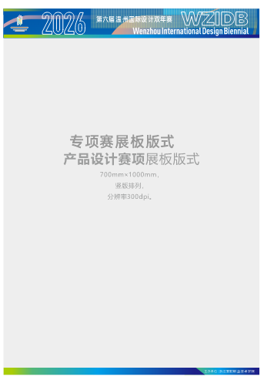

2.2. Works review images
The image format should be unified as JPG, with one 210mm * 290mm image and a brief design description attached. Horizontal and vertical unlimited, resolution of 300dpi, RGB mode. The size of a single image should not exceed 20M.
2.3 Video file description
Additional videos and roaming animations can be added, which is an additional item and not a mandatory requirement. The video format is MP4, and the demonstration video in the same competition topic should not exceed 100M, not be less than 20M, with a clarity of 1080p, a time limit of no more than 5 minutes, and a display ratio of 16:9 to ensure image quality.
2.4. Work description
The description should be within 200 words, and able to clearly express the creativity and content of the work.

3. Award Setting
This competition has two groups: professional group and student group, which will be evaluated separately, each with one gold award, two silver awards, three bronze awards, and several excellent awards. Winners will receive a certificate of award and corresponding prize money (before tax).
The bonus amount is as follows:
Category | Group | Gold Award | Silver Award | Bronze Award
Product  Design | Professional Group | 10000 | 8000 | 5000
Product  Design | Student group | 3000 | 2000 | 1000
The product prize includes model fees: the winning work model will be collected by the committee. If the participating work is not suitable for collection, a reduced version model can be made. If the value of the work exceeds the bonus, the participants can negotiate to make up the difference.

