Attachment 2:
2026 Wenzhou International Design Biennial
Requirements and Specifications for Environmental Art Design Group

1. Scope of works
1.1. Collect design with the integration of traditional culture and modern technology, centered around green cities, smart cities, and cultural cities, includes but is not limited to regional landscape environments, indoor and outdoor architectural decorations, and cultural innovations such as commercial spaces, livable spaces, community renovations, ecological communities, and cultural towns.
1.2. Collect design that highlight publicitiy and openness, enhance the interaction between citizens and buildings, create a vibrant atmosphere in the area, and drive the district to become a highly popular and culturally innovative cultural block and community design.
1.3. Collect design related with the revitalization of rural areas, showcase folk culture and art, and solicit buildings with rich local cultural characteristics, including but not limited to rural residences, homestays, cultural halls, and indoor and outdoor designs.

2. Specifications of submission
2.1. Pictures of environmental art exhibition boards:
Two exhibition boards with a vertical layout of 800mm × 1200mm and a resolution of 300dpi. The image content should include but not be limited to simple design explanations, design schemes, and real-life materials.
The image format should be unified as jpg or CMYK mode, and the size of a single image should not exceed 80M. The environmental art plate should include a brief design description that can assist in explaining the design intention and features of the work. The number of characters is not limited, but the language and text should be in Chinese (traditional or simplified) or English. The display board should have a graphic recognition template for the Wenzhou International Design Biennial Competition, which can be downloaded from the official website (http://wzdb. zjcst. edu. cn/). As shown in the following figure;
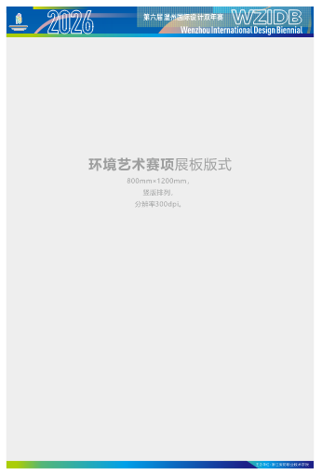
2.2. Works review images
The image format should be unified as JPG, with one 210mm * 290mm image and a brief design description attached. Horizontal and vertical unlimited, resolution of 300dpi, RGB mode. The size of a single image should not exceed 20M.
2.3 Video file description
Additional videos and roaming animations can be added, which is an additional item and not a mandatory requirement. The video format is MP4, and the demonstration video in the same competition topic should not exceed 100M, not be less than 20M, with a clarity of 1080p, a time limit of no more than 5 minutes, and a display ratio of 16:9 to ensure image quality.
2.4. Work description
The description should be within 200 words and able to clearly express the creativity and content of the work.

3. Award Setting
This competition has two groups: professional group and student group, which will be evaluated separately, each with one gold award, two silver awards, three bronze awards, and several excellent awards. Winners will receive a certificate of award and corresponding prize money (before tax).
The bonus amount is as follows:
Category | Group | Gold Award | Silver Award | Bronze Award
Environmental Art Design | Professional Group | 5000 | 3000 | 1000
Environmental Art Design | Student group | 2000 | 1000 | 800

